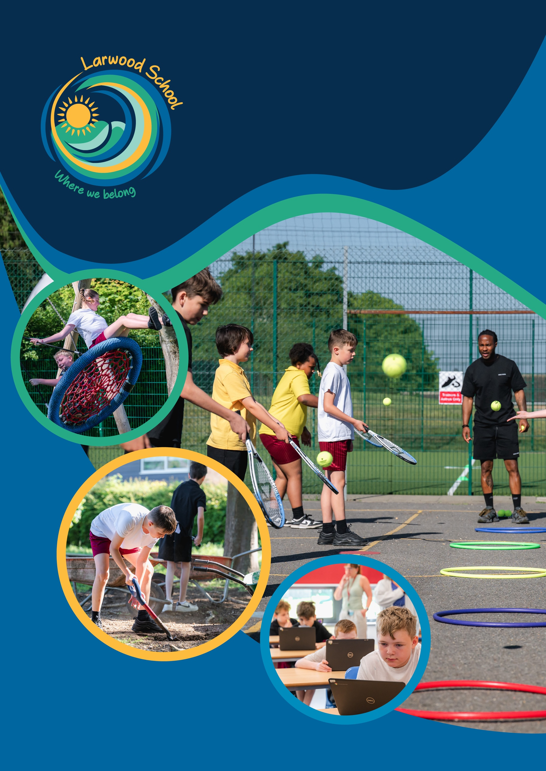
w
Admissions
2026


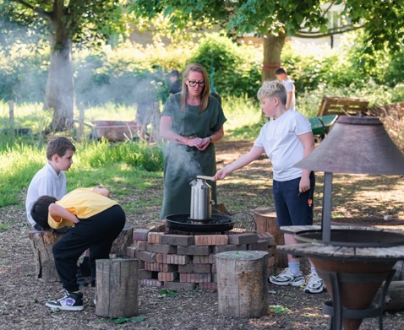
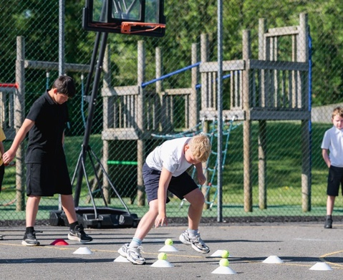
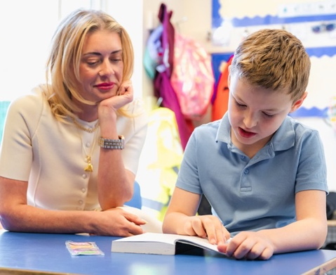
We provide a nurturing environment for children with social, emotional, and behavioural difficulties.

Our school values are at the heart of everything we do:
ENJOY
Enjoy every lesson, every day and enjoy your time at Larwood!
EXPECT
Expect to learn, expect to grow and develop in all areas of your education
BELIEVE
Believe in yourself, believe in others and be part of a positive team
ACHIEVE
Achieve all you can by listening, looking and learning
Larwood School
Executive Headteacher
Mr. Pierre van der Merwe
Acting Headteacher
Mrs. Bianca Osobu
Welcome to
Our experienced staff work closely with children, parents, and carers to provide a personalised and supportive learning environment. We aim to help children develop the skills and confidence they need to succeed in life.
Address
Larwood School, Larwood Drive, Stevenage, Hertfordshire, SG1 5BZ
Contact
Telephone: 01438 236333
Email: admin@larwood.org.uk


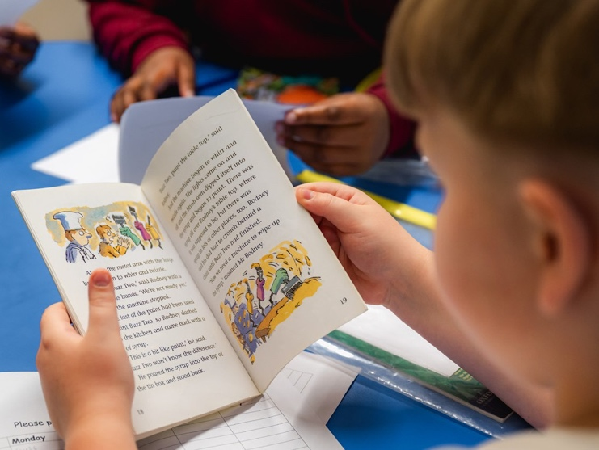
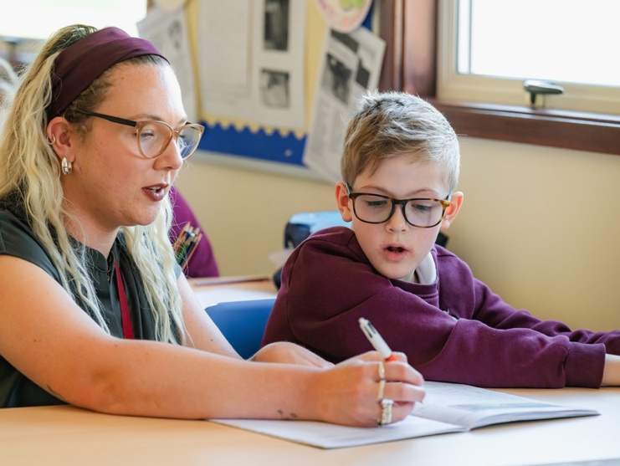
Table of Contents
Page
Communication Information 03
Interventions Parent Pack 05
Reading Books Consent Forms 09
Term Dates 2025-2026 10
New Pupil Information 11
Transport to School Letter 12
Medication Consent Form 13
Behaviour Management Consent Form 16
Home School Agreement 17
Image Consent Form 18
Pupil ICT Agreement 20
Uniform Policy 21
Ethnic Background 23
Pupil Code of Conduct 24
Food Information 25
Class Dojo 26
Swimming Consent Form 27
Drop Off and Pick Up Procedures 28
Space Hub – A Guide for Parents and Carers 29







































If
you
find
reading
or communication
challenging,
please
don’t
hesitate
to
ask
for
help.
Our
staff members
are
here
to
support
you
and
can
guide
you
through
this
information
in
whatever
way
works
best
for
you.
We
want to
ensure
you
understand
everything
about
your
child’s
admission
and
can
discuss
any
questions
or
concerns
you
may
have.

Interventions
Below is just a handful of the interventions we offer as part of our bespoke child centred approach. All children take part in academic interventions daily including phonics, reading and core math’s skills.

Overview of specialist interventions offered at Larwood School
Lego Therapy – During a Lego-based therapy session, three or four children of similar ages and abilities work together to build a Lego model following.
Lego-Based Therapy is a social development programme that uses Lego activities to support the development of a wide range of social skills within a group setting.
Speech and Language – Via SALT recommendations – The children and young people's (CYP) speech and language therapy service offers a child- and family-centred approach to support CYP with speech, language, and communication needs (SLCN) and those with eating and drinking difficulties in Hertfordshire. We work in partnership with parents, carers, health, and education professionals to promote positive outcomes for CYP. Our service model aims to reduce the gap and inequalities amongst CYP in Hertfordshire who have SLCN. The school delivers the SAL intervention after discharge from service and delivers it weekly 1-1 by school staff and keeps it on the monitoring caseload.
Thera play – When a child is struggling emotionally or finding their education difficult, we tend to try and work out what is going wrong for them. Ann Jernberg developed the Thera play method after realising that understanding what is going right for children who are thriving can also help us to understand how to support children experiencing difficulties. The foundation for lifelong emotional health and resilience is centred on the child’s relationships with the important adults in their life. Healthy relationships should provide moments of engagement and nurture, as well as safely structured opportunities to experience challenge. Thera play supports children and their caregivers through attachment and play-based interventions that strengthen the relationships between them. Delivered via MIM assessment, a 6-week programme of support and next steps family support and sharing techniques delivered. We have 5 Thera play practitioners on staff and it is a 2-1 intervention.
Mental Health Support Team – NHS Emotionally Based School Avoidance (EBSA). OCD. Tics/Tourette’s,
Traumatic Stress, Eating Disorders, self-harm, anxiety workshops (group or individual). Understanding my autism/ADHD programmes, space to Pause, Anxiety, Low Mood, parent support, staff training and consultation, support with escalating pathways of support through NHS. Three workers in school per week currently offering 1-1 and 3-1 sessions across these areas of need.

The Butterfly Room – External therapeutic referral The Butterfly room specialises in supporting children with ASD/ ADHD and their co morbid mental health. We support children suffering with anxiety, panic disorders, OCD, challenging behaviour, emotion regulation difficulties, TICS, and psychosis. We provide a safe, calm, understanding environment for children and families offering flexibility (and fun!) for children whilst helping them overcome their challenges and fulfil their potential. The Butterfly Room is proud to be able to deliver a range of therapeutic interventions, provided by a range of therapists including Behavioural Therapy, Cognitive Behavioural Therapy, Art Therapy, Play Therapy, Counselling and Psychotherapy. We work with children from as young as 4 years old and support children, young people, and adults. We work closely with many other agencies and services within Hertfordshire and Bedfordshire along with a large amount of both primary and secondary schools. We are proud to say that The Butterfly Room is based on the Larwood site, and we have worked in collaboration with them for many years. They also offer screening assessments for ADHD and ASD to speed up the service for our pupils. We fund this ourselves when pupils are on the exceptional need pathways and intervention can last between 12 weeks to their entire time with us at Larwood, the offer is based on need.
SPACE HUB – Please see attached info specific for SPACE HUB as this describes why this intervention is levelled as Exceptional need and or Specialist Plus.
Therapy ponies/goats – PIXIE AND PICKLES THERAPY PONIES / PIXIE AND PICKLES.

ADVENTURES – To be recognised as a provider of unique therapy pony visits to all our clients. Our mission is to bring together the best staff and volunteers who are dedicated to developing excellent pony therapy environments and delivering the highest quality of therapy pony care.
OUR VALUES
- Driving Therapy pony excellence
- Doing the right thing
- Caring is our passion
- Keeping it simple
- Delivering on our promises
- Succeeding and celebrating together

Strawberry fields farm goats and chickens – Hands-on experience with rare breed goats, alpacas, and chickens. We look forward to welcoming you to our 25-acre farm based near Welwyn in Hertfordshire with good transport links and beautiful countryside views. We aim to provide vulnerable people with the
opportunity to gain hands on experience caring and bonding with our social animals and assisting with farm- based activities. We offer a calm safe space and a friendly team with facilities and onsite parking. Care farming and the healing powers of animals can benefit health, wellbeing, and social skills, which in turn increases self- esteem. It builds independence, communication, and positive thinking all whilst learning transferrable skills.

Protective Behaviours The first theme ‘We all have the right to feel safe all the time’ incorporates the concepts of ‘Rights and Responsibilities’, ‘Safety’ and ‘Early Warning Signs’. The second theme ‘There is nothing so awful, or too small, we can’t talk about it with someone’ develops the concept of personal ‘Networks’ of support.
Delivered 1-1 (S+) and small group work (S) for 6 weeks and then reviewed to continue or maintain.
Forest School - Forest School is a child-centred inspirational learning process, that offers opportunities for holistic growth through regular sessions. It is a long-term program so that children can experience nature in all its forms and can witness first-hand how things change during the seasons. Forest school supports play, exploration and supported risk taking. It develops confidence and self-esteem through learner inspired, hands-on experiences in a natural setting. As leaders we provide a safe and inspiring learning environment, whilst allowing the children to take the lead in their own learning and experiences. Forest School has a developmental ethos shared by thousands of trained practitioners around the world. All trained practitioners must base their sessions around this Ethos which is:

- Forest School is a long-term process of regular sessions, rather than one-off o infrequent visits; the cycle of planning, observation, adaptation, and review links each session.
- Forest School takes place in a woodland or natural environment to support the development of a lifelong relationship between the learner and the natural world. Forest School uses a range of learner-centred processes to create a community for being development and learning.
- Forest School aims to promote the holistic development of all involved, fostering resilient, confident, independent, and creative learners. Forest School offers learners the opportunity to take supported risks appropriate to the environment and to themselves.
- Forest School is run by qualified Forest School practitioners, who continuously maintain and develop their professional practice.

Smart Moves Programme - Motor Skills Development programme, aimed at KS1 & KS2 devised by Sharon Drew, an OT and teacher. Assists in the identification of motor co-ordination difficulties. Provides a range of activities which reflect the PE curriculum and uses school resources. Provides a means for monitoring and evaluation.

Cooking - Full time interventionist who offers group and 1-1 cooking sessions to support areas across all areas of SEN and social care, neglect, and nurture pathways, dietary needs, OT and sensory needs. Each pupil has a programme of intervention lasting a term and a bespoke pathway which is followed based on the areas of need detailed within the EHCP. Each session is assessed, written up and shared with staff and parents, which feeds into the next steps planning.
CUB – Cub is a nurture space within school that offers targeted small group and 1-1 sessions for pupils who require a heavy nurture input on top of our baseline offer. The children access social, emotional, and mental health support delivered through Thera play techniques and ensures all our pupils have an offer of intensive nurture to foster their development across their areas of need detailed in their EHCP. This space is also used to deliver protective behaviours, and work intensively with our pupils who display harmful sexualised behaviour within school.
Animal Assisted Therapy – The Animal Assisted Therapy (AAT) is a health intervention, meant to improve physical, social, emotional, or cognitive functioning, with animals as integral part of the treatment. The therapeutic use of animals was argued for decades, and many associations employ this intervention to improve care. AAT is a structured, a goal-directed intervention in which an animal is incorporated as an integral part of the intervention process. AAT is delivered and/or directed by a professional health or human service provider who demonstrates skill and expertise regarding the clinical applications of human-animal interactions. AAT is documented and evaluated within an individualised support plan linked to their students EHCP. Sessions generally have a fixed length, and at the end of the session, the practitioner provides a detailed written report which will be shared with you, and external professionals.
Therapeutic Art – The goal of therapeutic art is to utilise the creative process to help people explore self- expression and, in doing so, find new ways to gain personal insight and develop new coping skills. Therapeutic art is documented and evaluated within an individualised support plan linked to their students EHCP. Sessions generally have a fixed length, and at the end of the session, the practitioner provides a detailed written report which will be shared with you, and external professionals.
Sand Tray Therapy – We have a full time specially trained member of the team to deliver the session will encourage the child to express themselves by creating a safe, imaginary world with a variety of figurines, toys, and props. These objects might include “real life” figurines such as trees, people, houses and animals, or imaginary figurines, like wizards and monsters. These toys and tools, which are carefully selected, allow the child to create aspects of their inner or outer worlds in a tray of sand. These objects represent words and the person’s creation is a language. Sand tray therapy is a healing process which helps children work through any painful conscious or unconscious memories. At the end of the session, the practitioner provides a detailed written report which will be shared with you. The sessions are child led and do not rely on verbal communication.
AMO (adapted meaningful opportunities) – AMO was devised and developed in 2023, to support the pupils within our trust who’s SEMH needs are so significant that they are unable to maintain a safe placement within the trust schools. This is a highly bespoke unit within our school that offers a highly adapted offer for our students with the aim of keeping them in education and to prevent permanent exclusion. Pupils access core learning and bespoke sessions with practitioners who are employed to deliver, Outdoor Education, Music making/DJ, Graphic design, Gardening, Art, Computing, cooking, and hands on learning opportunities. Staff ratios are extremely high and the pupils accessing AMO are referred based on their risk of permanent exclusion based on their significant SEMH needs.

Reading at Larwood Primary School
At Larwood Primary School, we believe that reading is a vital part of a child's education. We encourage all children to develop a love of reading and provide opportunities for them to read a wide range of books and they read to an adult as school daily.
No Homework Policy
We do not set traditional homework, but we do encourage children to read regularly at home. We believe that reading is an essential skill that can be developed and enjoyed outside of the classroom.
Boom Reader
We use an online platform called Boom Reader to log reading records and track progress. Children can read books from home, our school library, or online using resources such as Reading Owl.
Reading Books Consent Form
We ask parents and carers to sign a consent form to acknowledge their understanding of our reading policy. This includes:
- Recording pages read and making comments in the reading record on Boom Reader Returning the reading record book to school daily
- Reimbursing the school for any lost or damaged books
- Supporting Your Child's Reading
We are happy to discuss how you can best support your child's reading development and provide further advice if needed. Please contact your child's class teacher if you have any questions or concerns.

Consent Form

Pupil's name: ....................................................................................................... Date: .....................................................

I am happy to take part in the reading at home policy and understand that I will be required to reimburse the
School for any books that are not returned.

Print name: ........................................................................................................... Signature: .............................................

Relationship: ........................................................................................................ Date: .....................................................

By signing this form, you are acknowledging that you understand and agree to our reading policy. If you have
Any questions or concerns, please do not hesitate to contact us.

Term Dates

SPRING TERM 2025 | SCHOOL CLOSES | SCHOOL OPENS
Term Starts |  | 6th January
Spring Half Term Break | 17th February | 21 February
Last day of Term | 4th April 13.30pm Finish
End of Term Break | 7th April
SUMMER TERM 2025
Term Starts |  | 22nd April
May Day Bank Holiday | 5th May | 6th May
Summer Half Term | 26 May | 30 May
Summer Holidays | 18th July
AUTUMN TERM 2025
Term Starts |  | 28 August
Autumn Half Term Break | 20th October | 31st October
Occasional Day | 8th December | 9 December
Christmas end of Term Break | 22nd December

SPRING TERM 2026 | SCHOOL CLOSES | SCHOOL OPENS
Term Starts |  | 5th January
Spring Half Term Break | 16th February | 20th February
Last Day of Term | 27th March (1pm Finish)
End of Term Break | 30th March | 10th April
SUMMER TERM 2026
Term Starts |  | 13th April
May Day Bank Holiday | 4th May | 5th May
Summer Half Term | 25th May | 29th May
Summer End of term | 17th July (1pm Finish)
AUTUMN TERM 2026
Term Starts |  | 2nd Sept
Autumn Half Term Break | 19th October | 2nd November
Occasional Day | 30th November | 1st December
Christmas end of Term Break | 18th December (1pm Finish) | 4th January 2027

Administration Record
Pupil Registration
The information which is requested in this document may be stored on a computer and, if so, it is subject to the Data Protection Act 1984. The Act requires that all information is strictly confidential and may only be accessed by those with a legal right to see it, e.g. if there is a child protection enquiry. The information will not be given to anyone else without your written consent.
You have a right to examine, at any reasonable time, information about you or your child which is kept on a computer. You have a right to correct any information which you feel is wrong or misleading. Please contact the Head Teacher if you wish to examine the information about you or your child which is kept on this computer.

Name of School: LARWOOD SCHOOL

Details of Child
Surname of Child:
Forenames: | Sex (Male or Female):
Date of Birth: | Year Group:
Address:
 | Post Code:
Telephone Number:
Position of Child in Family: (please circle)  1 2 3 4 5 | Name of Previous School (if any):

Details of other children in the family:
Name | Date of Birth | School

Details of Parents:
Name of Persons of whom the Child lives | Relationship to Child | Parental Responsibility  (Y / N) | Telephone Number

Pupil Registration continued

When the child lives with someone other than his/her parent(s), the school needs details of those persons who have parental responsibility.
Name of others with parental responsibility | Relationship to Child | Address | Telephone Number
If parents are separated or divorced, has a court order been issued? Yes No

Who to contact if parents or carers cannot be reached in an emergency:
Name of Persons | Relationship to Child | Address | Telephone Number

Parent/Carer Email Address
Transport to School Information
When your child’s Education, Health, and Care Plan (EHCP) is finalised, and the nearest suitable school has been named, you need to contact Admissions and Transport for a home to school transport assessment. Please see contact details below to arrange this. We would advise that you contact the, as soon as you receive this letter to make an application for transport to start in the Autumn Term.
Admissions and Transport – 0300 123 4043
Please see link below which will give you more information about the transport service and the home to school transport policy. Both can be sent to you in paper or email form upon request from the Admission and Transport team.

https://www.hertfordshire.gov.uk/microsites/local-offer/education-support/help-you-can-get-when-your-child-is-in-school/send-home-to-school-transport.aspx

https://www.hertfordshire.gov.uk/media-library/documents/schools-and-education/admissions/transport-policies-and-documents/home-to-school-transport-policy-2020-21.pdf

Medication/Emergency Contact Form
Name D.O.B

Medical Information
a) Does your son/daughter suffer from any medical conditions requiring treatment or medication? YES/NO
(Please give details)
b) Has your son/daughter had any contact with infectious diseases in the last four weeks to your knowledge?
YES/NO
(Please give details)
c) Is your son/daughter allergic to any medication? YES/NO
(Please give details)
d) Has your son/daughter received a tetanus injection in the last five years?
YES/NO Date
e) Has your child had all their childhood inoculations? YES/NO
f) Is there any medical condition that we should be aware of, if it should become necessary to restrain your child? YES/NO
g) Has your child had all developmental checks? YES/NO
h) Are there any conditions we need to be aware of? YES/NO
If YES please give details below:

Medication
Name/Type of Medication (as described on the container)
For how long will your child take this medication
Full Description of use
Dosage and Method
Timing
Special Precautions
Side Effects
Self-Administration
Procedures to take in an Emergency
I understand that I must deliver the medicine to school and hand over to a member of staff and accept that this is a service which the school is not obliged to undertake.
Headteacher’s Permission:
Signed:
Date:

Administration of Antiseptic Wipes & Plasters
I give permission for my child………………………………………………………………to receive the above medical attention by staff at the school and obtain details from the school nurse if required.

Signed: Print Name:
Relationship to Pupil:

This form must be signed by someone with parental responsibility for the named child
Child’s name:
Date of Birth:

Declaration: I understand that my child may leave the school premises for local visits as outlined in the school visits policy and hereby give my consent for my child to participate in such visits. I also understand that my child may leave the school premises at other times when I will be informed separately by letter and at such times further consent will be required from me.

I agree that
- Can participate in the visits and activities described
- Can be transported in the school car/minibus or a hired minibus or coach
- Can be transported in the private vehicles of staff supervising the visit providing appropriate business use insurance is in place. This is checked at school.
- Is in good health and fit to participate in trips and activities
- Can receive medical treatment as necessary
I undertake the need for the child named above to behave responsibly and agree to the school’s procedures in this respect

Signed: Print Name:

Relationship: Date:

Behaviour Management Consent Form
Larwood School aims to work in close partnership with parents and carers to provide a safe and stable, consistent and supportive environment.
During pre-admission meetings the behaviour management structure and policy is explained and parents/carers are informed that they need to read the Trust Behaviour Policy, Larwood Behaviour Procedures and the Child Protection Policy before signing this document.
The school policy sets out the objectives and explains the way we work. This is reviewed annually and available on our website. More information is available on request.

Pupil’s name:
I am in receipt of the school’s behaviour management policy. I understand the school aims to work positively with pupils. I understand that occasionally it may be necessary to physically restrain and/or direct my child. The school aims to minimise the use of physical restraint by the use of behaviour support strategies which encourage children to make better choices. Physical restraint will only be used if a child is behaving in a way that is considered a criminal offence, likely to cause or is causing physical harm to others, themselves or serious damage to property.
I undertake to work in partnership with school communicating and visiting as appropriate. In return the school aims to be welcoming, open and effective when communicating with parents.

Print Name:

Signature:

Date:

Home School Agreement Copy
This agreement must be considered alongside the school behaviour management policy, which gives information about the ethos and aims of the school. We believe in active, supportive and co-operative partnership between home and school. We believe this is fundamental to challenging pupils’ behaviour and making educational progress.

Parents/Carers
I/we will
Ensure my child attends School regularly, on time and properly equipped;
Inform the school by phone and in writing if my child is absent;
Let the School know about any concerns or problems that might affect my child’s work or behaviour;
Support the School’s policies and guidelines for behaviour;
Support my child in homework if set and other opportunities for home learning;
Attend medicals, parents’ meetings and discussions about my child’s progress;
Get to know about my child’s life at the school;
Return any school resources lent to my child in good condition.

Pupil
I will
Wear the school uniform and be tidy in appearance;
Do all my class work as well as I can;
Be polite and helpful to others;
Behave appropriately and safely on the way to and from school;
Follow the school rules and expectations;
Have fun.

We will
Care for your child’s safety and happiness:-
Provide a balanced curriculum to meet the needs of our child;
Contact parents/carers if there is a problem with attendance, punctuality or equipment;
Let parents/carers know about any concerns or problems that affect their child’s work or behaviour;
Send home weekly home/school contact books;
Let parents know of good work and behaviour;
Arrange parent/carer meetings during which progress will be discussed;
Keep parents/carers informed about School activities through regular letters home, and notices about special events.

Signed: (Parent/Carer)

Signed: (Pupil)

School Image Consent Form
Dear Parent/Carer,
As part of our school’s educational activities and development, we regularly capture images and videos of pupils participating in school life. These may be used in various contexts, and we require your consent for their use.

Purpose of Image Use
Images and videos may be used for:
- School website and social media
- Printed and electronic publications
- Educational displays within the school
- School promotional materials
- News media coverage of school events
- Internal educational platforms

Conditions of Use
- This consent remains valid for the duration of your child’s attendance at our school You may withdraw consent at any time by writing to the school
- We will only use images that show the school and children in a positive light
- No embarrassing or distressing images will be used
- Children will never be identified by their full name alongside their image
- Only group or class photographs will be used with general captions (e.g., ‘Year 3 Science Project’)
- All children will be appropriately dressed in photographs
- Special care will be taken regarding pupils who are ‘at risk’ or have specific restrictions Images will be stored securely and used only for their intended purpose

Online Safety
Our school website can be viewed worldwide
We follow strict guidelines from our Local Education Authority
For online safety information, visit:
Local authority guidance: thegrid.org.uk/safeguarding-and-child-protection/online-safety

Please note: While we will take all reasonable measures to ensure images are used solely for their intended purpose, we cannot guarantee control over how images may be used by third parties once published online.
Return this form to: School Office
For office use only:
Date received:
Processed by:

National guidance:

www.thinkuknow.co.uk/parents

Consent Options
Please indicate your preferences by ticking the appropriate boxes:
- I give permission for my child’s image to be used in school publicity materials, including printed and electronic publications, video recordings, and the school website.
- I give permission for my child’s image to be used by news media in printed and electronic form, including their archives.
- I give permission for my child’s image to be used in internal educational platforms only (password-protected, visible only to school staff and parents/carers).
- I do not want my child’s image used in any publicity.
Declaration
Child's Name:
Parent/Carer's Name (block capitals):
Parent/Carer's Signature:
Date:

Acceptable Use of ICT Agreement / eSafety Rules

- I will only use ICT in school for school purposes.
- If using technology provided by school, I will only use it for school purposes even when not at school, i.e. using school Chromebook at home.
- I will only use my class email address or my own school email address when emailing.
- I will only open email attachments from people I know, or who my teacher has approved.
- I will not tell other people my ICT passwords.
- I will only open/delete my own files.
- I will make sure that all ICT contact with other children and adults is responsible, polite and sensible. I will not deliberately look for, save or send anything that could be unpleasant or nasty. If I accidentally find anything like this, I will tell my teacher immediately.
- I will not give out my own details such as my name, phone number or home address. I will not arrange to meet someone unless this is part of a school project approved by my teacher and a responsible adult comes with me.
- I will be responsible for my behaviour when using ICT because I know that these rules are to keep me safe.
- I know that my use of ICT can be checked and that my parent/carer contacted if a member of school staff is concerned about my eSafety.

We have discussed this and ............................................................................................................ (child’s name) agrees to follow the eSafety rules and to support the safe use of ICT at Larwood School.

Parent/Carer Signature:

For children aged 8 and over please sign to say you agree to the rules

Child’s Signature: Class: Date:


Larwood School – Uniform Policy
We want you to be comfortable at school so we allow for choices. It’s important to wear a uniform so we all look part of Larwood School.
What happens if you do not wear a uniform to school?
- We would ask that parents contact school if there is an issue with wearing the school uniform for any reason so that we can work with you to find a solution.
- Contact will be made with home if school uniform is not adhered to and it may affect your ability to earn your points if non-uniform is due to behavioural refusal.
- Pupils are allowed to wear sky blue coloured shirt/dress/playsuit once they have achieved ‘coloured shirt’ status by earning 90+ points for 6 weeks +
- Children should wear white or charcoal socks/tights.
- Shoes required: Black school shoes/PE trainers/black plimsols.

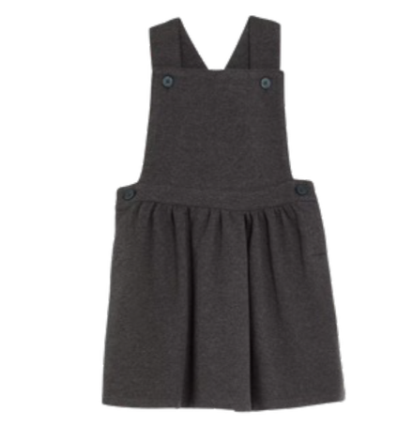

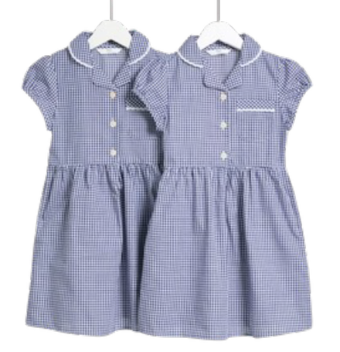





You can purchase the school uniform directly from: https://www.schooltrends.co.uk/
Charcoal Dress/Skirt
Navy Gingham Dress/Skirt
Navy Polo OR Navy T-Shirt
Charcoal Trousers/Shorts OR Charcoal Jogging Bottoms
Larwood School – Uniform Policy


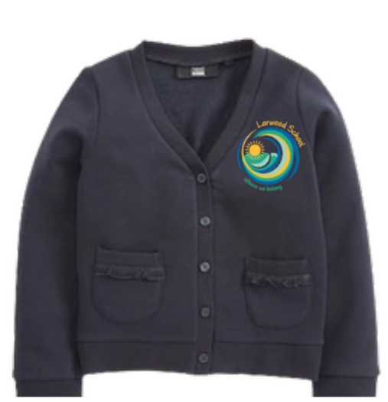





You can purchase the school uniform directly from: https://www.schooltrends.co.uk/
Navy jumper, cardigan or fleece are all acceptable
White Polo OR White T-Shirt
Navy Jogging Bottoms OR navy PE Shorts
PE Days

APPENDIX A
Ethnic Background Record Form
COUNTY COUNCIL
Children, Schools & Families
(based on the new national population Census ethnic categories)
Our ethnic background describes how we think of ourselves. This may be based on many things, including, for example, our skin colour, language, culture, ancestry or family history. Ethnic background is not the same as nationality or country of birth.
The DƒES recommends that those with parental responsibility decide the ethnic background for primary pupils. The Information Commissioner (formerly the Data Protection Registrar) recommends that young people aged over 11 years old have the opportunity to decide their own ethnic identity. Parents, or those with parental responsibility, are asked to support or advise those children aged over 11 in making this decision, wherever necessary. Pupils aged 16 or over can make this decision for themselves.
Please study the list below and tick one box only to indicate the ethnic background of the pupil or child named above. Please also tick whether the form was filled in by a parent or the pupil.
(a) White British Irish
Traveler from Irish heritage Gypsy/Roma
Any other White background
(c) Asian or Asian British
Indian Pakistani Bangladeshi
Any other Asian background
(b) Mixed
White and Black Caribbean White and Black African White and Asian
Any other mixed background
(d) Black or Black British
Caribbean African
Any other Black background
(f) Any Other Ethnic Group
(e) Chinese
I do not wish an ethnic background to be recovered
Please return the form to the school within four weeks in the enclosed envelope, or by dropping it into the office.
(Any information you provide will be used solely to compile statistics on the school careers and experiences of pupils from different ethnic backgrounds, to help ensure that all pupils have the opportunity to fulfil their potential. These statistics will not allow individual pupils to be identified. From time to time the information will be passed on to the Local Education Authority and the Department for Skills and Education (DƒES) to contribute to local and national statistics. The information will also be passed on to future schools to save it having to be asked for again).

This information was provided by: ......................................... Parent Pupil
Pupil’s Name:

Class/Form:

Form 3688

Sanctions
For negative behaviour will:
- Reminder of rules/ expectations
- Warning of consequences
- Time away
- Playtime detention
- After school detention Internal exclusion
- Fixed term exclusion

Rewards
For positive behaviour will be:
- Smiles
- Praise
- Certificates
- Stickers
- Friday afternoon activities
- Letter/phone call home
- Privileges/responsibilities
Code of Conduct
Like all schools we have a ‘Code of Conduct’ relating to pupil behaviour whilst on the premises. All pupils and parents/carers are informed of this and asked to support it.
School Rules
- Are you safe?
- Can you be trusted?
Expectations
- I will be in the right place at the right time and ready to learn.
- I will always be safe when moving around school.
- I will keep my hands, feet, and hurtful remarks to myself.
- I will always respect belongings, school property and school buildings.
- I will always respect other people’s feelings and will not get involved in other people’s problems.

Food Information Form
Child’s Name
I give permission for my child to take part in food activities, which form part of the school curriculum.
She/he (please cross out the line/s which do not apply)
a) Can eat a variety of foods.
b) Should not eat the following foods.
c) Has food allergies (please list)

Other comments:

I also understand that if my child is ill, they will not be allowed to take part in food activities.

Signed: Print Name: Date:

Other Information
All pupils will be provided with a free school lunch which is a choice of a hot meal, a salad or a sandwich. Although we ask that you still apply for free school meals if you qualify, please follow the link
http://thegrid.org.uk/info/meals/index.shtml. Staff in class will help pupils make their choices for lunch a week in advance.

Dear Parents and Carers,
We are very excited to welcome you to our ClassDojo. This is a free online communication platform (and works in a similar way to Facebook). We have been working extremely hard to develop how we communicate with you. We are hopeful, that through using ClassDojo, we will be able to share many MAGIC moments as your child continues their learning journey.
Each child has a monster avatar. Your child can have lots of fun with this avatar and you will be able to celebrate your child’s achievements! Avatars can be personalised.
There are two very important areas within ClassDojo. These areas are the ‘Class Story’ and the ‘Portfolio’ areas. Within the ‘Class Story’ you will see posts shared by your child’s class teacher. Here you can comment on the class teacher’s posts and ‘like’ these to let them know that you appreciate their post. Other parents will be able to see any comments that you add to the class teacher’s posts in the ‘Class Story’ area.
In the ‘Portfolio’ area, you can respond to tasks set by your child’s teacher and upload your own pieces of work for your teacher to see. Each time you add a photo, video or any other message to the portfolio area, the class teacher has to approve these and can respond to your post in the comments section. You will also find that there is a messaging area on ClassDojo. Please ensure that you do check this area, as your teacher will send you a message daily with updates and initially with a link to set up your child access when you first begin to use ClassDojo. You must follow this link to be able to share any posts with us. With regards to messaging, we ask that you are courteous and abide to the following guidance below both now and when we do return to school;
DOs
- Please do message your child’s teacher if you have a small query about the work that has been set.
- The teachers will be professional at all times; we ask that you ensure you use appropriate language and remember that there is a person that wants to help you on the other side of the screen.
DON’Ts
- Please do not message your child’s teacher to notify them of absences or illnesses – this should be done via the school office as normal.
- Please do not use Class Dojo to message about any urgent or serious issues; please use the school office and normal school procedures for this.
The parts of ClassDojo we use are free for us at school and for you at home. There is a section called ‘ClassDojo Beyond School’ which allows you to award dojo points as a parent but this is a subscription service. Please be mindful of this and do not enter any payment details if you do not want to be charged.
Teachers will always endeavour to reply or acknowledge posts in a timely fashion. However, please bear in mind that staff can be very busy working hard and as I am sure you know, school life can be very hectic. This means that there may be a slight delay on occasion, even more so when we do return to a more ‘normal’ school life.
We hope this answers any questions that you may have and we look forward to communicating with you through ClassDojo.
Regards,
Mrs Osobu
Head of School

Swimming Consent Form
Dear Parent/Carer,
As part of the National Curriculum requirements, swimming lessons are a compulsory component of your child's physical education. These lessons will take place for one full term at Stevenage Swimming Centre.
Transportation will primarily be provided by school vehicles, though on occasion, pupils may walk to the facility accompanied by staff. All swimming lessons will be conducted by qualified Stevenage Swim coaches, and Larwood School staff will always be present to supervise the children.
Please complete the consent form below and provide the required medical information. You will be notified of the exact dates and times of swimming lessons closer to the start of the term.

SWIMMING CONSENT
I hereby give permission for my child to:
Participate in swimming lessons at Stevenage Swimming Centre
Travel by school vehicle or walk when necessary
Be supervised by Larwood School staff and taught by Stevenage Swim coaches
Child's Name:
Date of Birth:

Medical Information:
Please provide details of any medical conditions/diagnosis:
Current Medications:
Any additional information (e.g., allergies, special requirements):

Emergency Contact Details
Name: Phone:
Parent/Carer Signature: Date:
Please return this completed form to the school office as soon as possible.
Note: Children can only be exempt from swimming with a valid medical certificate from a healthcare professional. For any queries, please contact the school office.











Drop Off and Pick Up Procedures
Morning Drop Off:
- Join the queue on the left side of Larwood Drive, entering from Webb Rise
- Please queue considerately, ensuring you do not block resident driveways
- School staff will direct you through the school gate just before 9:00
- Form two rows of cars by circling to the front of the round about
- Wait for staff to signal when your child should exit the vehicle
- Children will independently make their way into school
- Remain in your car at all times
- Do not drive away until directed by staff to ensure children's safety when crossing

Afternoon Pick Up (Monday-Thursday 3:20/Friday 2:20):
- Join the queue as per morning procedure
- Follow staff directions at all times
- Children will be called via radio when we see your car
- Staff will coordinate children safely to vehicles

Important Notes:
- If you need to speak with staff members, please park in a designated space
- If your child needs extra time to enter/exit the vehicle, please park rather than joining the queue
- This system is designed to maintain safety and efficiency during busy periods
- Always follow staff instructions to ensure everyone's safety

Success Stories
Many parents have described the changes in their children as "life-changing." Some students have successfully transitioned back to the main school setting after receiving support through our intervention programme.
Our Purpose
The main objectives of Space Hub are to help your child:
- Achieve academic success
- Develop self-confidence and self-identity
- Learn self-regulation skills
- Master essential life skills
- Improve social interaction abilities

How We Support Your Child
- Structured Environment
- Clear daily routines with visual timetables
- Minimal transitions to reduce anxiety
- Differentiated activities that children can choose from
- Small group settings (Earth, Moon, and Stars sones)

Positive Approach
- Continuous positive reinforcement
- Points-based reward system
- Special achievement recognition
- Safe and nurturing environment to build confidence

Specialised Features
- Sensory support tools (toys, trays, ear defenders)
- Dedicated calming spaces
- Access to forest school activities
- Life skills training (cooking, cleaning, gardening)
- Educational trips and experiences

Communication and Support
- Regular parent communication through Class DOJO
- Phone calls and meetings as needed
- Updates on your child's progress
- Collaborative approach with families

What Makes Us Different?
- Low arousal environment following SPELL Framework
- Small class sizes with high staﬀ-to-student ratio
- Individualised learning approaches
- Focus on both academic and life skills
- Access to mainstream school facilities when appropriate
Space Hub - A Guide for Parents and Carers
What is Space Hub?
Space Hub is a specialised intervention area established in November 2019, designed specifically for children with Autism, LD presentation and who have Educational Health Care Plans (EHCP). It currently offers 16 places and is staffed by a dedicated team including a lead teacher, an HLTA, and three LASAs.
Our Commitment
We are committed to providing your child with the same opportunities as their peers while ensuring they receive the specialised support they need to thrive. Our experienced team understands autism and works to create an environment where your child can feel safe, valued, and successful.
For more information or to discuss your child's speciﬁc needs, please don't hesitate to contact us. We believe in building strong partnerships with parents and carers to ensure the best possible outcomes for your child.

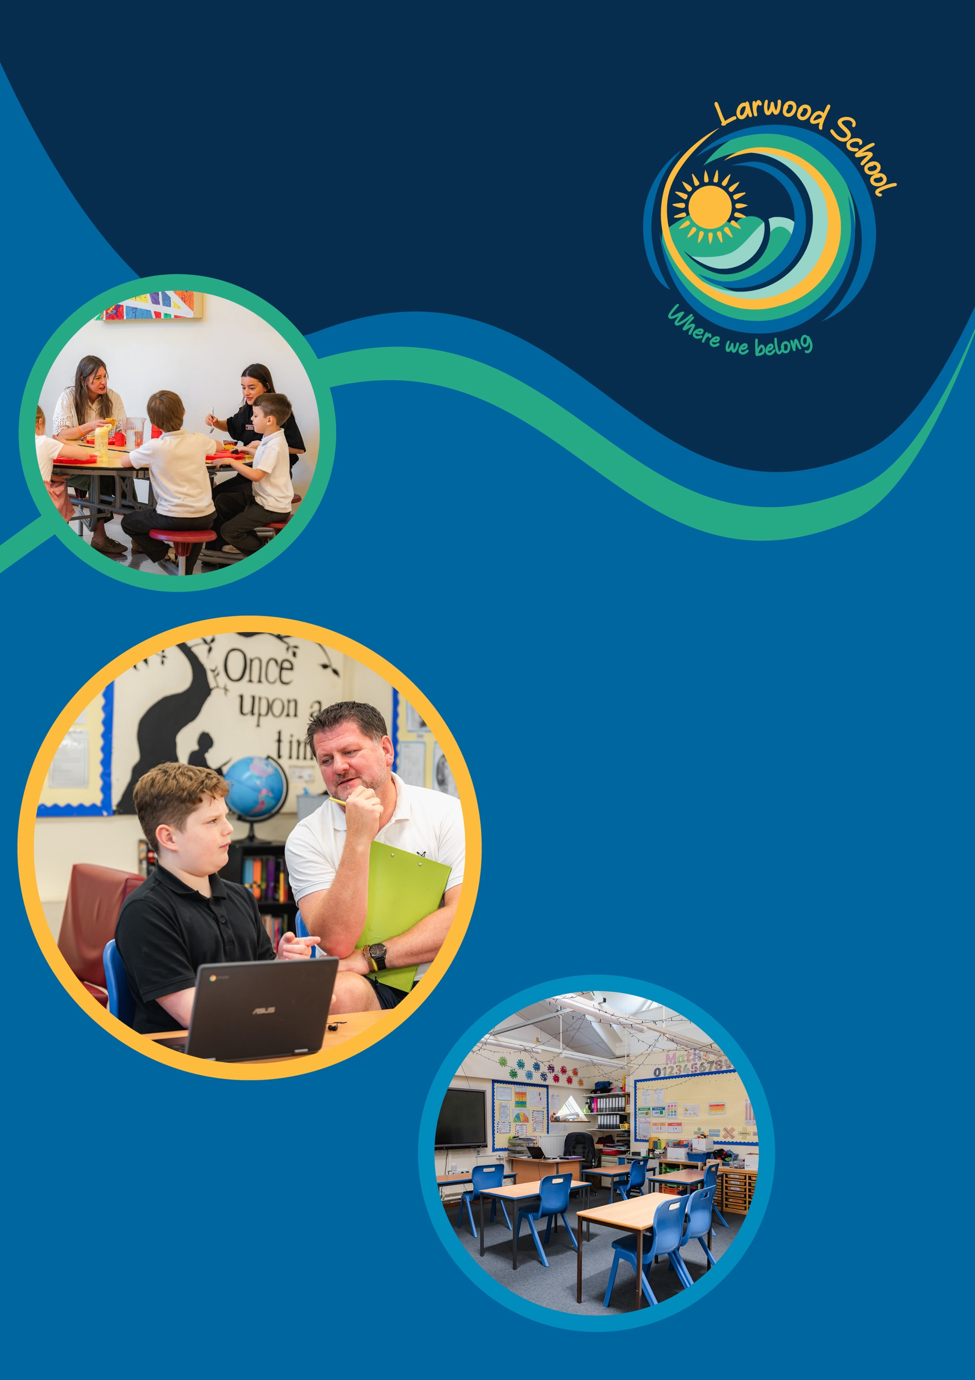
Executive Headteacher
Mr. Pierre van der Merwe
Acting Headteacher
Mrs. Bianca Osobu
Address
Larwood School, Larwood Drive, Stevenage, Hertfordshire, SG1 5BZ
Contact
Telephone: 01438 236333
Email: admin@larwood.org.uk

